Operator’s Manual

Rice Hull Blower

RHB-001

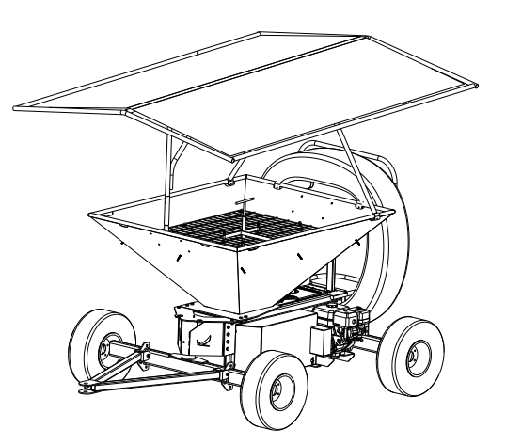

 

# Thank You for Purchasing a STILT.PRO Product

We appreciate having you as a customer and wish you many years of safe and satisfied use of your machine. Before delivering this machine, STILT.PRO performed a predelivery inspection and run in to ensure best performance.

We want you to get the best results from your new machine and how to operate it safely. This manual contains information to help you with that. This manual is an important part of your machine and should remain with the machine when you sell it.

Reading your operator’s manual will help you and others avoid personal injury or damage to the machine. Information given in this manual will provide the operator with the safest and most effective use of the machine. Knowing how to operate this machine safely and correctly will allow you to train others who may operate this machine.

Sections in your operator’s manual are placed in a specific order to help you understand all the safety messages and learn the controls so you can operate this machine safely. You can also use this manual to answer any specific operating or servicing questions. A convenient index located at the end of this book will help you to find needed information quickly.

The machine shown in this manual may differ slightly from your machine but will be similar enough to help you understand our instructions.

RIGHT-HAND and LEFT-HAND sides are determined by facing in the direction the machine will travel when going forward.

# CALIFORNIA Proposition 65 Warning

|  |
| --- |
| WARNING: The Engine Exhaust from this product contains chemicals known to the state of California to cause cancer, birth defects or other reproductive harm.  California Proposition 65 warning |
| WARNING: The Engine Exhaust from this product contains chemicals known to the state of California to cause cancer, birth defects or other reproductive harm.  California Proposition 65 warning |

# A Few Words About Safety

Your safety and the safety of others are very important. And using this equipment safely is an important responsibility.

Your manual contains special messages to bring attention to potential safety concerns, machine damage as well as helpful operating and servicing information. Please read all the information carefully to avoid injury and machine damage.

# Product Identification

See Product and Component Identification sheet for specific component make model and serial number.

### Serial Number Locations:

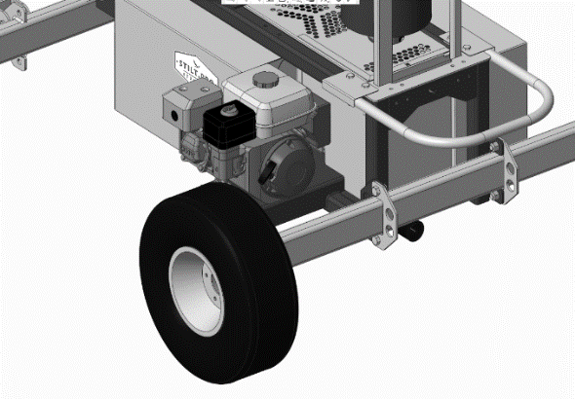

Engine Serial Number

Equipment Serial Number

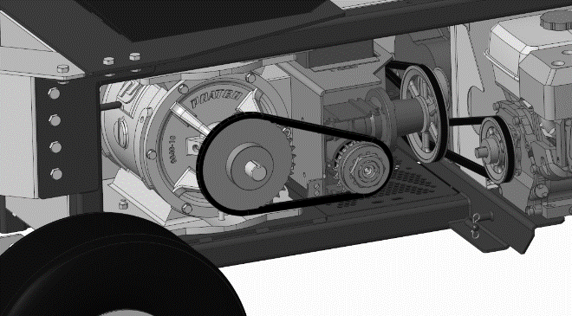

Airlock Serial Number

Gearbox Serial Number

Blower Serial Number

# Safety Labels

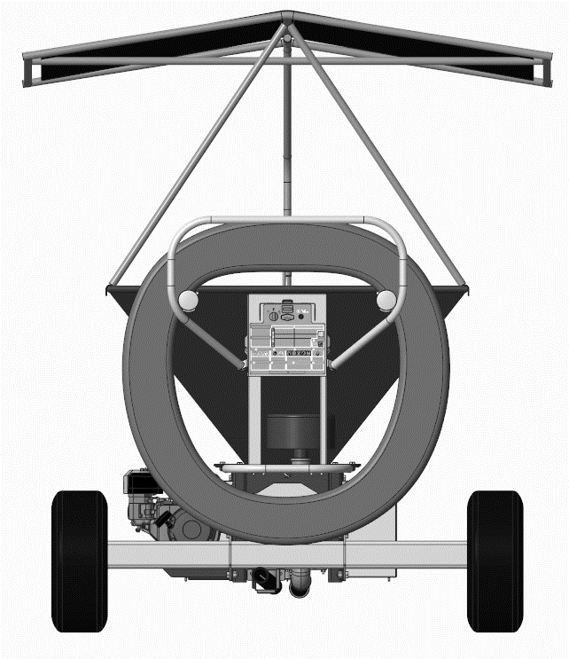

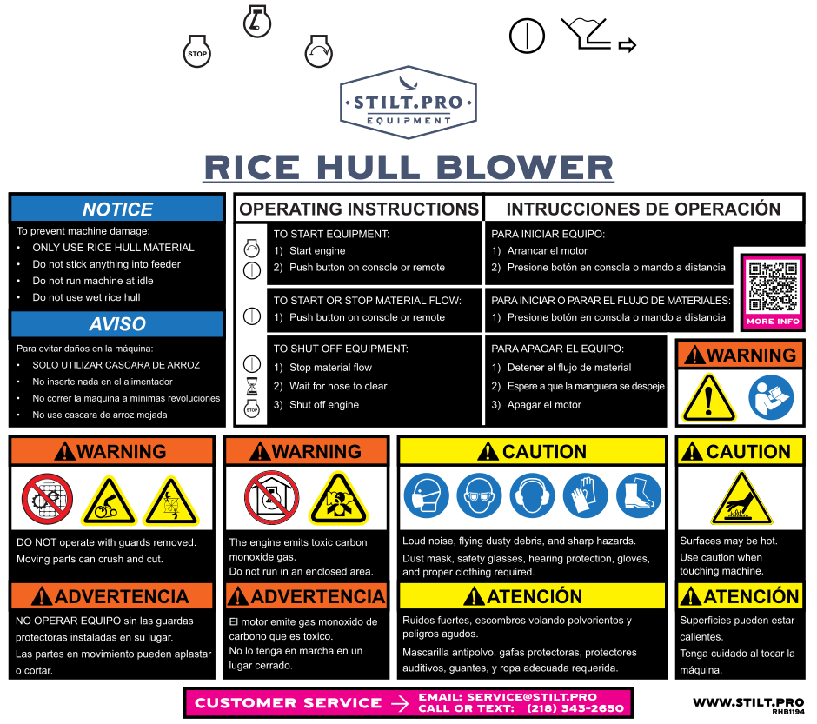

## Understanding the Machine Safety Labels

The machine safety labels shown in this section are placed in important areas on your machine to draw attention to potential safety hazards.

On your machine safety labels, the words DANGER, WARNING, and CAUTION are used with this safety-alert symbol. DANGER identifies the most serious hazards.

The operator’s manual also explains any potential safety hazards whenever necessary in special safety messages that are identified with the word, CAUTION, and the safety-alert symbol.

There can be additional safety information contained on parts and components sourced from suppliers that is not reproduced in this operator’s manual.

|  |  |
| --- | --- |
|  | WARNING   * DO NOT operate with guards removed. * Moving parts can crush and cut.   ADVERTENCIA   * NO OPERAR EQUIPO sin las guardas protectoras instaladas en su lugar. * Las partes en movimiento pueden aplastar o cortar. |
|  | WARNING   * The engine emits toxic carbon monoxide gas. * Do not run in an enclosed area.   ADVERTENCIA   * El motor emite gas monoxido de   carbono que es toxico.   * No lo tenga en marcha en un   lugar cerrado. |
|  | CAUTION   * Loud noise, flying dusty debris, and sharp hazards. * Dust mask, safety glasses, hearing protection, gloves, and proper clothing required.   ATENCIÓN   * Ruidos fuertes, escombros volando polvorientos y peligros agudos. * Mascarilla antipolvo, gafas protectoras, protectores auditivos, guantes, y ropa adecuada requerida. |
|  | WARNING   * Read and understand operator’s manual and all other safety instructions before using this equipment.   ADVERTENCIA   * Leer atentamente el manual del usuario y todas las instrucciones correspondientes de seguridad, entaes de usar este equipo. |
|  | CAUTION   * Surfaces may be hot * Use caution when touching machine   ATENCIÓN   * Superficies pueden estar calientes. * Tenga cuidado al tocar la máquina. |
|  | NOTICE   * To prevent machine damage: * ONLY USE RICE HULL MATERIAL * Do not stick anything into feeder * Do not run machine at idle * Do not use wet rice hull   AVISO   * Para evitar daños en la máquina: * SOLO UTILIZAR CASCARA DE ARROZ * No inserte nada en el alimentador * No correr la maquina a mínimas revoluciones * No use cascara de arroz mojada |

## Operating Instruction Label

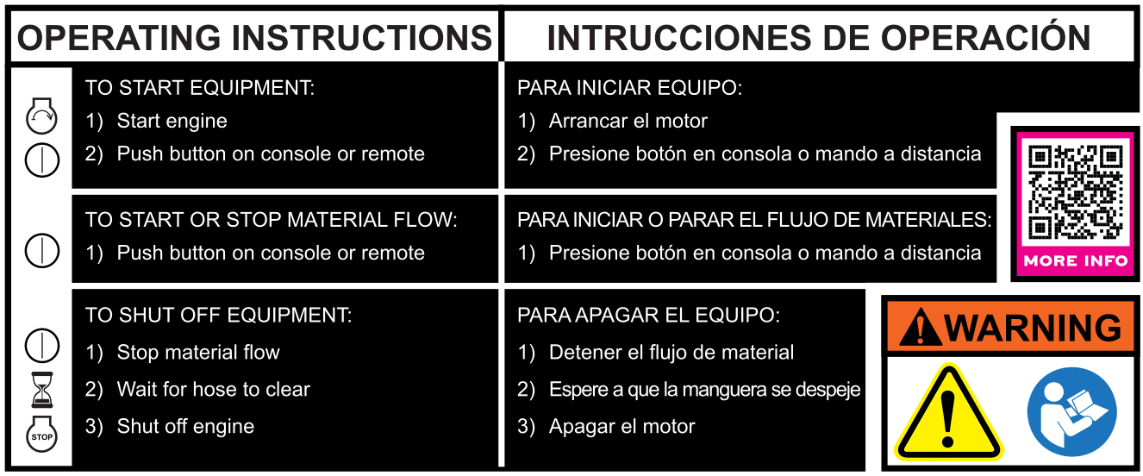

# SAFETY

## Operating Safely

This is an industrial piece of equipment and has components which could cause bodily harm to the operator if used improperly or if safety guards and/or systems are removed. Failure to observe the following safety instructions could result in serious injury or death.

* Read, understand and follow all instructions on the machine and in manuals provided before starting. Be thoroughly familiar with the controls and the proper use of the machine before starting.
* Do not put hands or feet near rotating parts. Always keep clear of the discharge opening.
* Only allow responsible adults, who are familiar with the instructions, to operate this machine.
* Never direct discharged material toward anyone.
* Do not operate the machine without all guards in place, or other safety devices in place and working.
* Never leave a running machine unattended.
* Always turn off feeder, stop engine and remove key before removing covers or after use.
* Shut off engine and wait for all parts to come to a complete stop before cleaning the machine, removing the covers, or unclogging the system.
* Operate machine only in daylight or good artificial light.
* Do not operate the machine while under the influence of alcohol or drugs.
* Use extra care when loading or unloading the machine into a trailer or truck.
* Always wear proper PPE when operating equipment.
* Inspect machine before you operate. Be sure hardware is tight. Repair or replace damaged, badly worn, or missing parts. Be sure guards and shields are in good condition and fastened in place. Make any necessary adjustments before you operate.
* Make sure spark plug, muffler, fuel cap and air cleaner are in place before starting the engine.
* Do not change the engine governor settings or overspeed the engine. Operating the engine at excessive speed can increase the hazard of personal injury.
* If the machine appears to be plugged or not performing as expected, stop the machine and  
  inspect it. Make repairs before you operate.
* Use only accessories and attachments approved by the manufacturer of the machine. Keep safety labels visible when installing accessories and attachments.
* Do not wear radio or music headphones. Safe service and operation require your full attention.
* Do not ride on machine when it is being moved between locations.
* When machine is left unattended, stored, or parked, ensure the unit is properly situated so that it will not roll unexpectedly. Use tow vehicle parking system or wheel chocks to ensure equipment does not move unexpectedly.
* Do not operate this equipment on public roads. It is designed for off-road use only.

## Parking Safely

1. Stop machine on a level surface, not on a slope.
2. Disengage feeder.
3. Wind up hose.
4. Stop the engine.
5. Lock the park brake on tow vehicle.
6. Remove the key.
7. Wait for engine and all moving parts to stop.
8. Close fuel shut-off valve, if your machine is equipped.
9. Disconnect the negative battery cable or remove the spark plug wire(s) (for gasoline engines) before servicing the machine.

## Wear Appropriate Clothing

* Always wear a dust mask, safety glasses, hearing protection, gloves, and proper clothing.
* Wear close fitting clothing and safety equipment appropriate for the job.
* While operating this machine, always wear substantial footwear.

## Practice Safe Maintenance

* Only qualified, trained adults should service this machine. Understand service procedure before doing work.
* Never operate machine in a closed area where dangerous carbon monoxide fumes can collect.
* Keep all nuts and bolts tight, to be sure the equipment is in safe working condition.
* Never tamper with safety devices. Check their proper operation regularly.
* Keep machine free of rice hull material, dirt or other debris build-up. Clean up oil or fuel spillage and remove any fuel-soaked debris. Allow the machine to cool before storing.
* If the machine jams from a foreign object, stop and inspect the machine. Repair, if necessary, before restarting.
* Never make any adjustments or repairs with the engine running. Wait for all movement to stop on machine before adjusting, cleaning or repairing.
* Periodically check hose condition and bottom feeder plate for material buildup or holes. Rice hull material can cause wear, damage, and deterioration which could cause reduced performance or problematic operation.
* Maintain or replace safety and instruction labels, as necessary.
* Keep hands, feet, clothing, jewelry, and long hair away from any moving parts, to prevent them from getting caught.
* Before cleaning or servicing machine. Disengage all power and stop the engine. Chock vehicle and remove the key. Let machine cool.
* Securely support any machine elements that must be raised for service work. Use jack stands or lock service latches to support components when needed.
* Disconnect battery or remove spark plug wire before making any repairs. Disconnect negative terminal first and positive last. Install positive terminal first and negative last.
* Charge batteries in an open, well-ventilated area, away from sparks. Unplug battery charger before connecting or disconnecting from the battery. Wear protective clothing and use insulated tools.

## Prevent Fires

* Machine fires and structure fires can occur if a machine is stored before allowing it to cool, if debris is not removed from critical areas of the machine, or if machine is stored near combustible materials.
* Remove rice hull and debris completely from drivetrain compartment and muffler area before operating machine.
* Empty material hopper completely before storing.
* Always shut off fuel when storing or transporting machine, if the machine has a fuel shutoff.
* Do not store machine near an open flame or source of ignition, such as a water heater or furnace.
* Check fuel lines, tank, cap, and fittings frequently for cracks or leaks. Replace if necessary.

## Handling Fuel Safely

**To avoid personal injury or property damage, use extreme care in handling fuel. Fuel is extremely flammable and fuel vapors are explosive:**

* Extinguish all cigarettes, cigars, pipes, and other sources of ignition.
* Use only an approved fuel container. Use only non-metal, portable fuel containers approved by the Underwriter’s Laboratory (U.L.) or the American Society for Testing & Materials (ASTM). If using a funnel, make sure it is plastic and has no screen or filter.
* Never remove the fuel tank cap or add fuel with the engine running. Allow engine to cool before refueling.
* Never add fuel to or drain fuel from the machine indoors. Move machine outdoors and provide adequate ventilation.
* Clean up spilled fuel immediately. If fuel is spilled on clothing, change clothing immediately. If fuel is spilled near machine, do not attempt to start the engine but move the machine away from the area of spillage. Avoid creating any source of ignition until fuel vapors have dissipated.
* Never store the machine or fuel container where there is an open flame, spark, or pilot light such as on a water heater or other appliance.
* Prevent fire and explosion caused by static electric discharge. Static electric discharge can ignite fuel vapors in an ungrounded fuel container.
* Never fill containers inside a vehicle or on a truck or trailer bed with a plastic liner. Always place containers on the ground away from your vehicle before fueling.
* Remove fuel-powered equipment from the truck or trailer and refuel it on the ground. If this is not possible, then refuel such equipment with a portable container, rather than from a fuel dispenser nozzle.
* Always keep the nozzle in contact with the rim of the fuel tank or container opening until the fueling is complete. Do not use a nozzle lock-open device.
* Never overfill fuel tank. Replace fuel tank cap and tighten securely.
* Replace all fuel container caps securely after use.

## Tire Safety

**Explosive separation of a tire and rim parts can cause serious injury or death:**

* Do not attempt to mount a tire without the proper equipment and experience to perform the job.
* Always maintain the correct tire pressure. Do not inflate the tires above the recommended pressure. Never weld or heat a wheel and tire assembly. The heat can cause an increase in air pressure resulting in a tire explosion. Welding can structurally weaken or deform the wheel.
* When inflating tires, use a clip-on chuck and extension hose long enough to allow you to stand to one side and NOT in front of or over the tire assembly.
* Check tires for low pressure, cuts, bubbles, damaged rims or missing lug bolts and nuts.

## Handling Waste Product and Chemicals

Waste products, such as, used oil, fuel, coolant, brake fluid, and batteries, can harm the environment and people:

* Do not use beverage containers for waste fluids - someone may drink from them.
* See your local Recycling Center or authorized dealer to learn how to recycle or get rid of waste products.
* A Material Safety Data Sheet (MSDS) provides specific details on chemical products: physical and health hazards, safety procedures, and emergency response techniques. The seller of the chemical products used with your machine is responsible for providing the MSDS for that product.

# Operating

## Control Locations

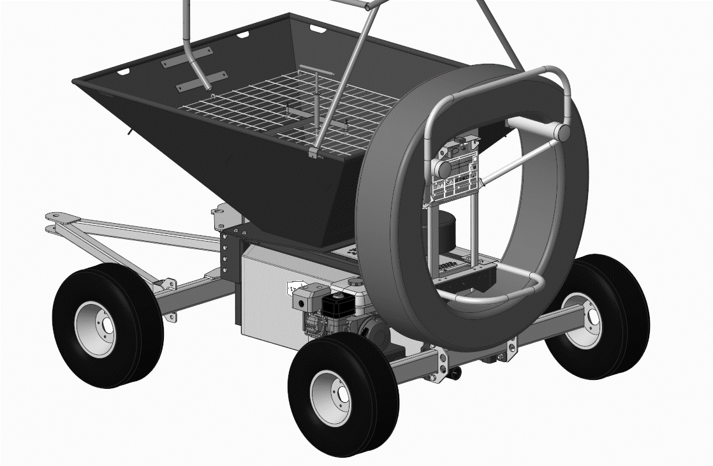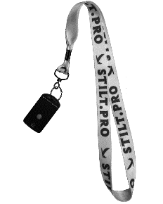

|  |  |  |  |
| --- | --- | --- | --- |
| **Key** | **Description** | **Key** | **Description** |
| A | Rice Hull Bridge Breaker | I | Carburetor Choke |
| B | Ignition Key Switch | J | Engine Air Filter |
| C | Hour Meter | K | Fuel Tank Cap |
| D | Start/Stop Material Flow | L | Tie Down Locations |
| E | Remote Control Storage Hook | M | Hose Coupler |
| F | Material Flow Indicator Lights | N | Remote Control |
| G | Blower Air Filter | O | Bag Knife |
| H | Engine Speed Control Lever |  |  |

## OPERATING

### Daily Operating Checklist:

* Check Engine Oil Level
* Check Engine Air Cleaner
* Check Blower Air Filter
* Check Tire Pressure
* Check Conveying Hose
* Check Fuel Level

IMPORTANT: Avoid damage! Using stale, contaminated or improper fuel can result in engine and fuel system damage. Repairs caused by stale, contaminated or improper fuel are not covered by warranty.

### Adjusting Machine

The rice hull blower is designed to operate at full throttle and there are no settings to adjust on the machine. Some components will wear and may require some adjustment through life. The primary adjustments required are belt and chain tensions. There are belt idlers that allow for additional slack to be taken from belt to extend life prior to belt replacement.

**To adjust chain due to stretching of chain:**

* Remove link from chain to tighten chain.
* Replace chain.

## Operating

### To Start Equipment

1. Move the fuel valve lever to the ON position, if equipped.
2. Move the throttle lever completely away from the MIN. position.
3. To start a cold engine, move the choke lever to the CLOSED position.
4. To restart a warm engine, leave the choke lever in the OPEN position.
5. For ELECTRIC STARTER - Turn the key to the START position and hold it there until the engine starts.
6. If engine fails to start within 5 seconds, release the key, and wait at least 10 seconds before operating the starter again.

**NOTICE**

Using the electric starter for more than 5 seconds at a time will overheat the starter motor and can damage it. This type of overheating is not covered under warranty.

1. When the engine starts, release the key, allowing it to return to the ON position.
   * If the choke lever was moved to the CLOSED position to start the engine, gradually move it to the OPEN position as the engine warms up.
2. For RECOIL STARTER – pull the starter grip lightly until you feel resistance, then pull briskly in the direction of the arrow as shown below. Return the starter grip gently.
3. Let engine run at full throttle for a couple of minutes to warm-up before operating machine.

### Idling the Engine

IMPORTANT: Avoid damage!

Unnecessary engine idling may cause engine or transmission damage. Excessive idling can cause engine overheating, carbon build-up, and poor performance.

Idling or low throttle operation while operating could result in blower overheating. Always operate at full throttle once the engine is warm.

### To shut off Equipment:

To stop machine in an emergency, simply turn the engine switch to the OFF position. Under normal conditions, use the following procedure.

1. Stop material flow.
2. Wait for hose to clear.
3. Move the throttle lever to the MIN. position.
4. Turn the engine switch to the OFF position.
5. Move the fuel valve lever to the OFF position.
6. Remove Key.
7. Ensure the machine is parked safely.

### Setting Engine Speed

The throttle lever should always be operated at full throttle.

### To start or stop material flow

Once engine is running at full throttle:



1. On startup - press the material flow button on the console or the remote. This will engage the blower.
2. Press the material flow button again. This will start material flow. The material flow indicator lights will turn on.
3. Press the material flow button again. This will stop material flow. The material flow indicator lights will turn off.

### Opening a bag of rice hull material

The blade used to open material bags is stored on the hopper guard.

IMPORTANT: avoid machine damage!

To prevent machine damage, do not use a knife that can fall through the guard.

### Long Term Storage

IMPORTANT: Long term storage requires several things to be completed to ensure a proper return to service when storage period is complete. The two issues that you will have from long term storage – rice hull material left in equipment will cause machine to lock up. Fuel will expire and cause engine malfunction.

**NOTICE**

Leaving rice hull material in the machine or allowing water to collect in hopper will cause unnecessary damage to equipment and is not covered under warranty.

1. Dispense all rice hull material so that hopper is completely empty.
2. Drain fuel from gas tank (follow manufacturer recommendation)
3. Start engine and then shut of fuel valve to allow fuel bowl on engine to empty.
4. Allow engine to stop from no fuel.
5. Uncoil hose and set on ground to prevent collapse or compression of hose from pressure of being installed on hose real for long periods of time.
6. Store in a dry location.

IMPORTANT: Avoid Damage!

Do not allow water to enter or accumulate in the hopper. Through use, the steel in the feeder will become bare. This will rust with water present and may damage equipment. Keep this area protected when not in use.

### Transporting machine on trailer.

NOTE: Trailer capacity must exceed combined machine weight and attachment weight. (See Specifications section in operator’s manual.)

Be sure the trailer has all necessary lights and signs required by law.

CAUTION: Avoid injury! Use extra care when loading or unloading the machine onto a trailer or truck.

* Park trailer on a level surface.
* Use of a trailer with sides is recommended.
* Keep wheels away from drop-offs and edges.
* Close fuel shut-off valve, if your machine is equipped.

IMPORTANT: Avoid damage! Transporting a machine on a trailer or on a truck bed at high speeds can result in canopy damage and possibly coming off machine.

1. Remove canopy tarp from structure.
2. Close fuel shut-off valve, if your machine is equipped.
3. Secure hose, ignition key, and remote control
4. Park trailer on a level surface.
5. Pull machine onto trailer.
6. Secure machine to trailer with heavy-duty straps, chains or cables. Straps must be attached to the indicated tiedowns on machine and directed outward from machine.

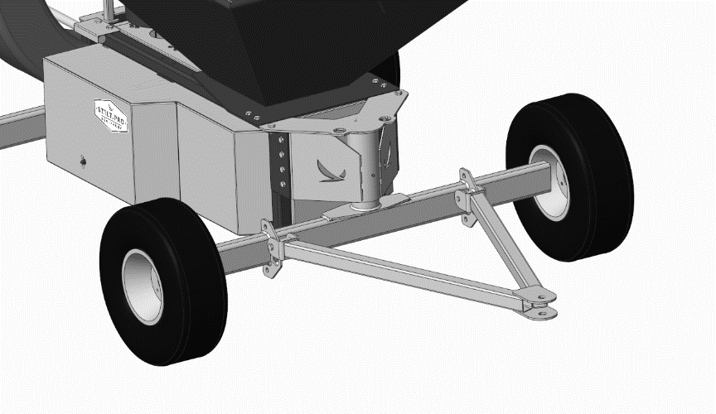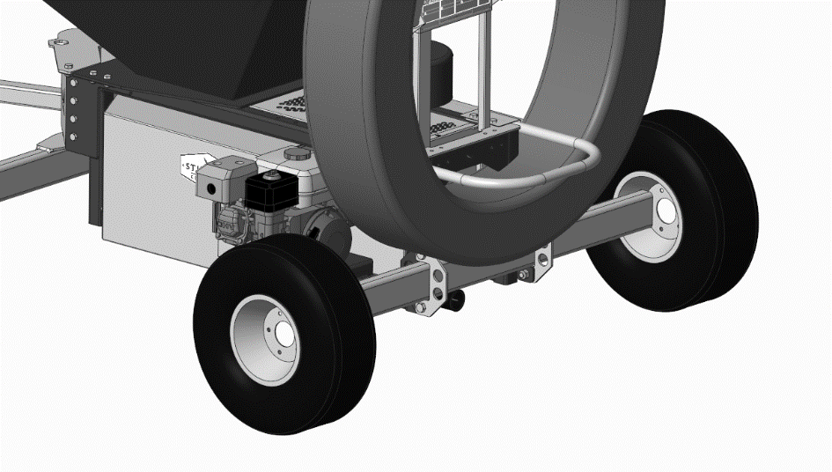

## Maintenance

### Servicing Your Engine

Follow recommended maintenance procedure provided by engine manufacturer.

### Servicing your Machine

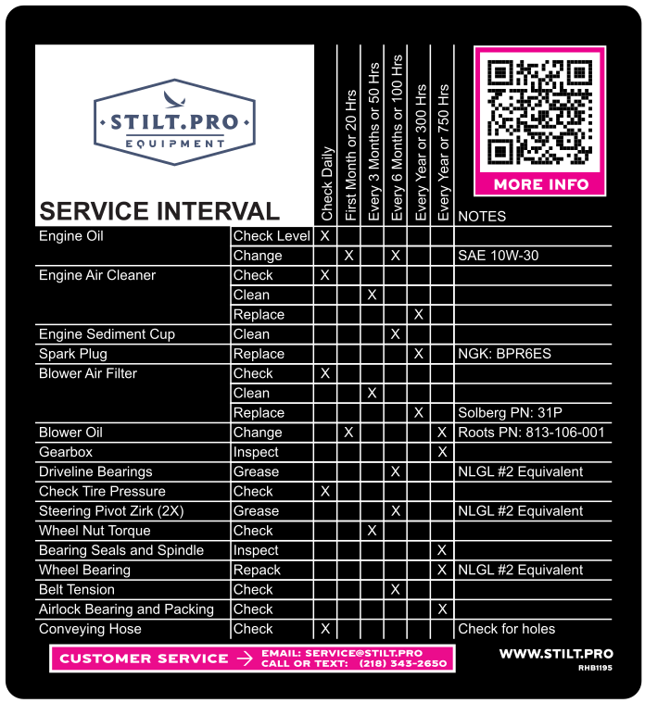

### Grease Locations:

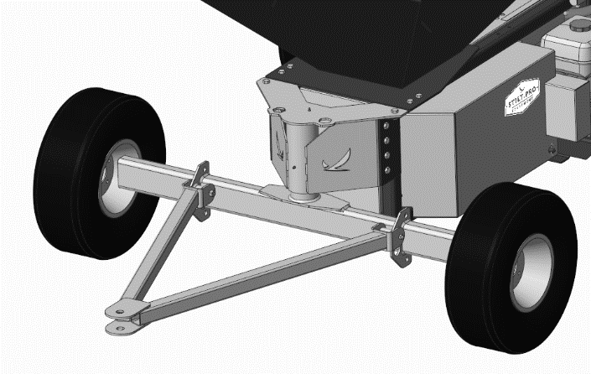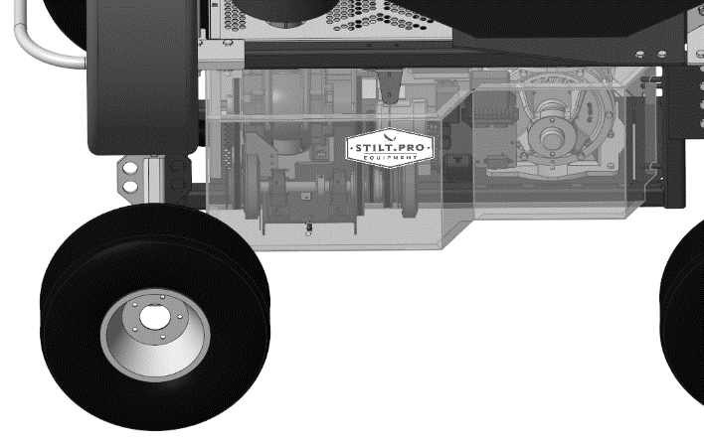

## Replacing Fuses

There are fuses and relays integrated into system to protect the circuit from overload. They are conveniently consolidated into a single location behind the Right-Hand Side cover. There is also a single automotive style relay to disconnect power to circuits during electric starting.

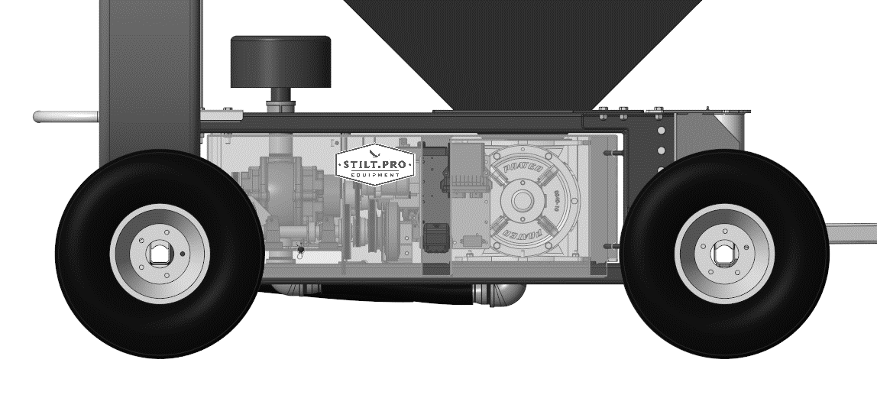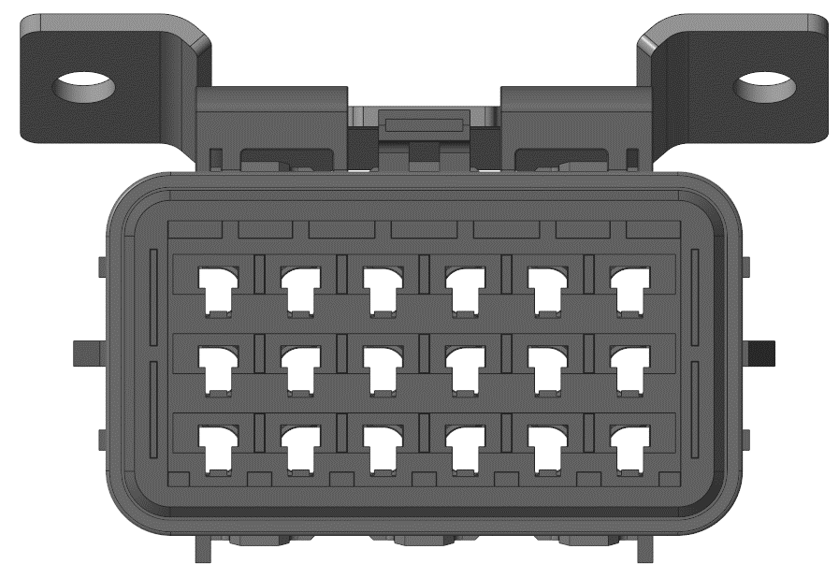

F

G

C

B

A

D

E

|  |  |  |
| --- | --- | --- |
| **Key** | **Description** | **Value** |
| A | Primary Fuse | 3 Amps |
| B | Feeder Clutch Fuse | 10 Amps |
| C | Blower Clutch Fuse | 10 Amps |
| D | Key Switch Fuse | 3 Amps |
| E | Blank |  |
| F | Feeder Clutch Relay | Contact STILT.PRO |
| G | Blower Clutch Relay | Contact STILT.PRO |

# Troubleshooting

## Machine is not feeding material or plugging

The machine is designed to perform trouble free and without adjustment. There may be several reasons material is not feeding material properly or is becoming plugged.

Check in the following order:

After traveling, the rice hull material may pack together and cause the material to bridge in the hopper. Use the bridge breaker in the hopper to clear the material and start material flowing again.

Verify that material being used is dry and free of contaminants. Wet rice hull or foreign material will cause problems with operation and will likely plug machine.

Verify that operator is running equipment at full throttle. If the machine is operated at a speed less than full throttle, there may be insufficient airflow to properly move the rice hull material.

Check that all belts are tight and in place.

### To clear a plugged line:

1. Turn off material flow
2. While machine is running, straighten out hose straight back from rear of machine
3. From the discharge end, pick up and shake hose to attempt to break clog free.

### To clear a plugged feeder:

1. Turn off material flow
2. While machine is running, remove plug on bottom of machine to allow material to blow out of bottom.
3. If there is minimal warm air coming from access hole, it may be plugged in blower line. This may be caused by a slipping blower belt.
4. If there is a lot of cool air coming out, the hose is plugged.

### If still plugged:

1. Remove hose from feeder on underside of machine
2. Attempt to unplug

### To check if feeder is turning:

1. Verify that feeder is turning by observing the feeder at front of machine. If unable to see in through top of machine because there is material present. The LH cover will need to be removed to observe this operation. Return cover as soon as verification is complete.

If feeder is jammed, seek manufacturer support to resolve.

### To remove bottom feeder to clean and unplug:

1. Turn off machine and properly lock out machine.
2. Remove side covers.
3. Remove 8 bolts holding feeder to bottom of machine.
4. Clean feeder.
5. Reinstall.

## Engine Troubleshooting

See manufacturers operator manual for engine troubleshooting

# Specifications

### Model RHB-001 Dimensions

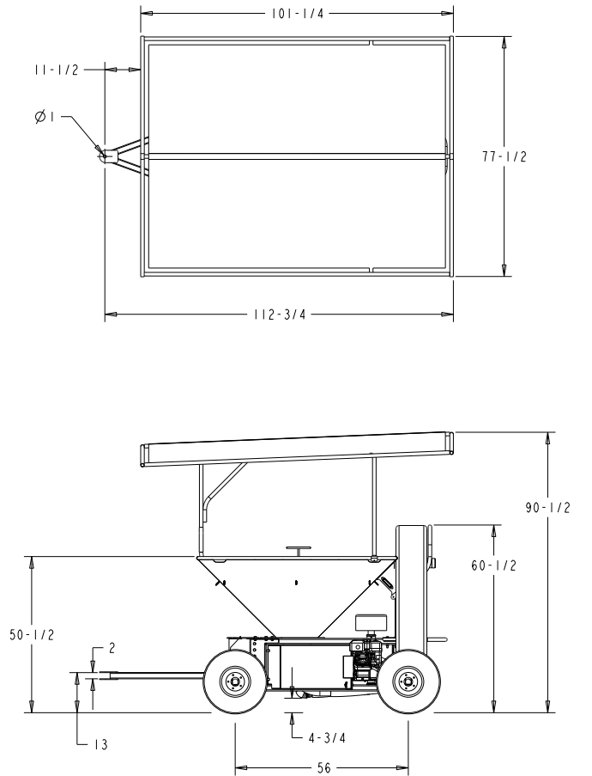

### Model RHB-001

|  |  |
| --- | --- |
| **Blower** |  |
| CFM | 140 |
| Reverse flow protection | Check valve |
| **Feeder** |  |
| Size | 8” |
| Protection | Overload clutch |
| **Electrical** |  |
| Battery Size/Type | U1L |
| Alternator | 40 Amp |
| System Voltage | 12 Volts |
| **Engine** |  |
| Make | Honda |
| Model | GX200 |
| Electric Start / Recoil | Both |
| **Recommended Lubricants / Wear Parts** |  |
| Engine Oil | SAE 10W-30 |
| Spark Plug | NGK: BPR6ES |
| Blower Air Filter | Solberg PN: 31P |
| Blower Oil | Roots PN: 813-106-001 |
| Grease | NLGI 2 or Equivalent |
| Dry Lube for Rice Hull Contact | John Deere Graphite Lubricant – PN TY25797 |
| Fuel Type | Regular Grade 87 Octane Unleaded Fuel |
| Primary Drive Belt | AX66 |
| Blower Drive Belt | AX30 |
| Feeder Drive Belt | AX54 |
| Alternator Drive Belt | 3L200 |
| **Sealed for life components** |  |
| Feeder Bearings and seals | No service required, only inspection |
| Gearbox oil | No service required, sealed for life. |
| **Equipment Dimensions** |  |
| Tire | 205/65-10 |
| General Dimensions | See diagram |
| Hose Real Capacity | 100ft 2” Hose |
| Wheel Bolt Pattern | 5 on 4.5” |
| Wheel Size | 10” Dia X 6” Wide |
| Canopy Dimensions | 6’ x 8’ Standard Tarp |

(Specifications and design subject to change without notice)

# Warranty

### Warranty Period and Limitations

This warranty is limited to the following STILT.PRO equipment: RHB-001 Rice Hull Blower

The equipment, excluding batteries, shall be warranted from all manufacturing defects for a period of **36 months** from date of original purchase. Batteries shall be warranted for a period of **3 months**.

### To Qualify for this Warranty:

This warranty applies to the first purchaser and each subsequent owner during the applicable warranty time period, unless noted otherwise.

### What STILT.PRO will Cover Under Warranty:

STILT.PRO will repair, replace or arrange for local repair through a 3rd party, at its option, any part that is proven to be defective in material or workmanship under normal use during the applicable warranty time period. Warranty repairs and replacements will be made without charge for parts or labor. Anything replaced under warranty becomes the property of STILT.PRO LLC. All parts replaced under warranty will be considered as part of the original product, and any warranty on those parts will expire with the original product warranty period.

### Exclusions:

1. Any damage or deterioration resulting from the following:
   * Damage to hose from misuse such as driving over or dragging of hose behind machine.
   * Damage to feeder assembly from an impact or introduction of foreign objects.
   * Damage from using equipment to dispense non rice hull product.
   * Exposure to or improper use of corrosive chemicals such as fertilizers.
   * Neglect of the periodic maintenance as specified in the product owner’s manual
   * Improper repair or maintenance.
   * Operating methods other than those indicated in the product owner’s manual.
   * Increasing engine speed beyond factory specification.
   * Collision, fuel contamination or deterioration, neglect, unauthorized alteration, misuse, incorporation or use of unsuitable attachments or parts.
   * Normal wear and tear (including, but not limited to, normal fading of painted or plated surfaces, rust, scratches or other surface imperfections)
   * Feeder assembly wear that does not impeded proper operation and function of system.
2. Consumable Parts: STILT.PRO does not warrant parts deterioration due to normal wear and tear. The following parts are not covered by this warranty unless they are needed during another repair covered under this warranty: spark plug, fuel filter, air cleaner elements, clutch disc, tire, wheel bearing, recoil starter rope, belt, oil and grease.
3. Cleaning, adjustment, and normal periodic maintenance work (carburetor cleaning, engine oil changing, blower oil changing, belt tensioning, feeder buildup cleanout)
4. Any product that has ever been declared a total loss or sold for salvage by a financial institution or insurer.
5. Feeder assembly is specifically not warranted against impact damage.

### Disclaimer of Consequential Damage and Limitation of Implied Warranties:

STILT.PRO LLC disclaims any responsibility for loss of time or use of the product, transportation, commercial loss, or any other incidental or consequential damage. Any implied warranties are limited to the duration of this written limited warranty. Some states do not allow limitations on how long an implied warranty lasts and/or do not allow the exclusion or limitation of incidental or consequential damages; therefore, the above exclusions and limitations may not apply to you. This warranty gives you specific legal rights, and you may also have other rights, which vary from state to state.

# INDEX

Thank You for Purchasing a STILT.PRO Product 2

CALIFORNIA Proposition 65 Warning 2

A Few Words About Safety 2

Product Identification 2

Safety Labels 3

Understanding the Machine Safety Labels 4

SAFETY 7

Operating Safely 7

Parking Safely 8

Wear Appropriate Clothing 8

Practice Safe Maintenance 8

Prevent Fires 9

Handling Fuel Safely 9

Tire Safety 10

Handling Waste Product and Chemicals 10

Operating 11

Control Locations 11

OPERATING 11

Operating 12

Maintenance 15

Replacing Fuses 16

Troubleshooting 17

Machine is not feeding material or plugging 17

Engine Troubleshooting 18

Specifications 18

Warranty 20



## For Questions, Comments, Support, or Concerns regarding anything with this machine or for STILT.PRO please contact:

|  |
| --- |
| Tom Knuth  [TomK@STILT.PRO](mailto:TomK@STILT.PRO)  (218) 343-2650  261 Quality Drive  Thomson, GA 30824 |

